### How to create Repo

### Create Repository

Step 1: Go to tab Repositories and click on New

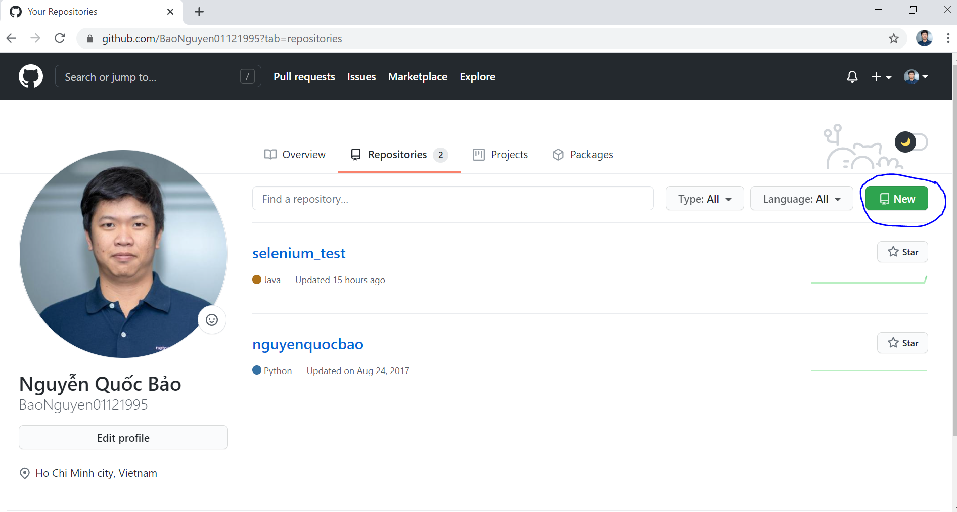

Step 2: Create a new name for the repo and click on Create Repository

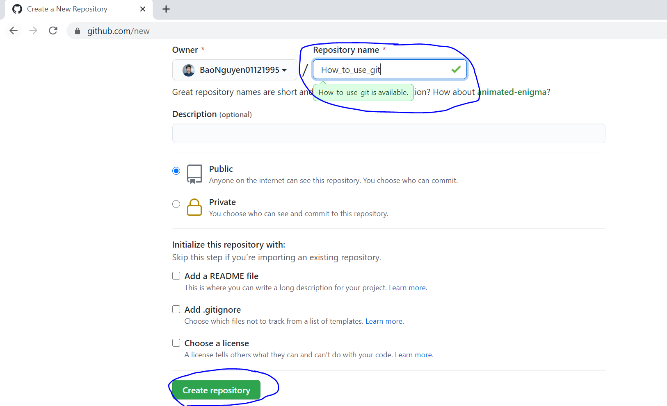

Step 3: Copy url and then git clone it

(by using “git clone https://github.com/BaoNguyen01121995/How_to_use_git.git”)

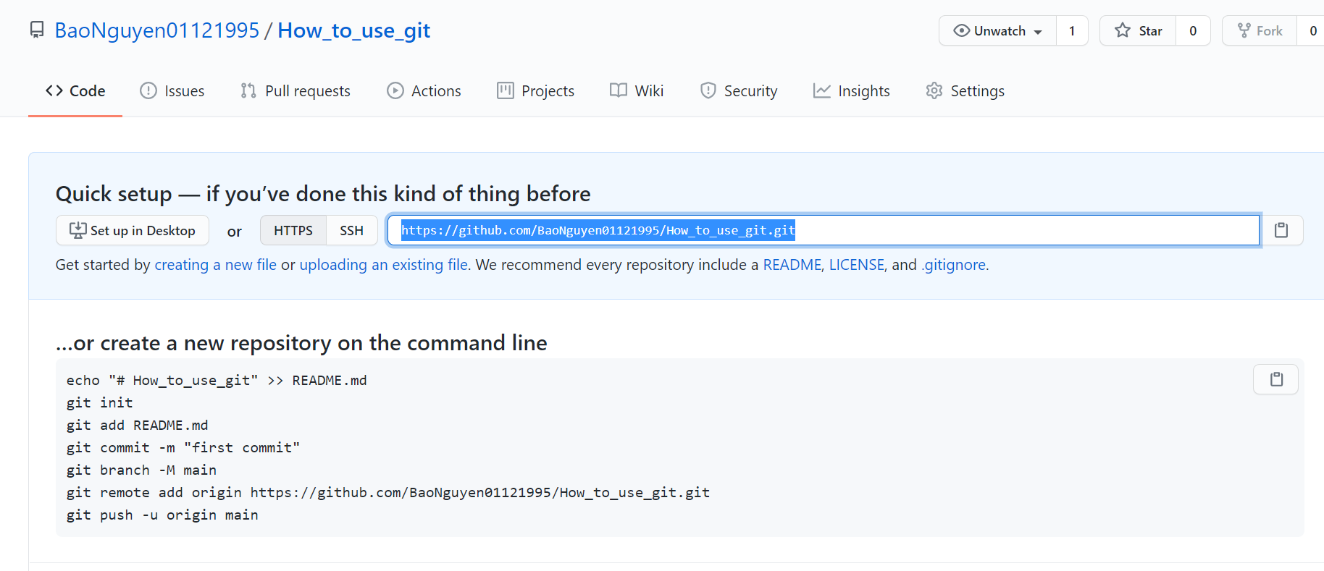

Step 4: Open git bash and check untracked files by using git status

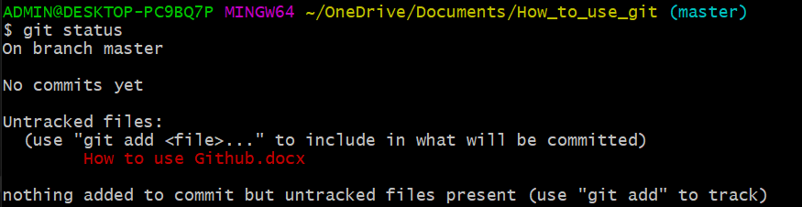

Step 5: Add file to git

Using the following commands: git add . or git add <file name>

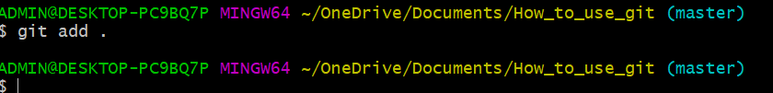

Step 6: Commit file by using command git commit –m “…<message>…”

Step 7: Push code to github by using command git push